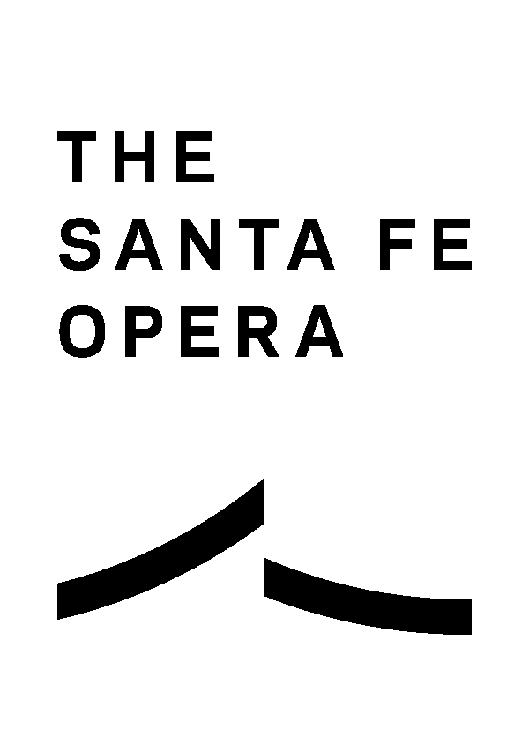
For Immediate Release

The Young Voices of the Santa Fe Opera
Present a Free Showcase on May 11 and Call For Applications From New Mexico Youth for the 2024/25 School Year

4 April, 2024
Emily Doyle Moore | media@santafeopera.org | 505-986-5908

Santa Fe, NM — The Young Voices of the Santa Fe Opera present “Young Voices, Timeless Music,” a free and delightful showcase of operatic and musical theater scenes on Saturday, May 11 at 3:00 pm at the Center for Contemporary Arts in Santa Fe. Showcasing the talent of tomorrow, the scenes are further complemented by costumes and props from Santa Fe Opera productions past. The 2024 class of Young Voices represents 11 students from 10 different schools across Northern New Mexico. Of seven graduating seniors, five will pursue a higher education in music. While admission to "Young Voices, Timeless Music" is free, reservations are required. Donations to support the Young Voices Program are welcome and can be made through the reservation link at: https://www.santafeopera.org/whats-on/young-voices-concert/.

For Calendar Keepers
"Young Voices, Timeless Music"
The Young Voices of Santa Fe Opera 2024 Scenes Showcase
Who: The Young Voices of the Santa Fe Opera
What: A public recital showcasing the talents of the 11 members of the Young Voices of the Santa Fe Opera
Where: Center for Contemporary Arts, 1050 Old Pecos Trail, Santa Fe, NM 87505
When: Saturday, May 11, 3:00 pm
Tickets: FREE; reservations required: https://www.santafeopera.org/whats-on/young-voices-concert/
Contact: For more information, please contact Amy Owens at youngvoices@santafeopera.org

Looking to the future, program applications for the 2024/25 class of the Young Voices of the Santa Fe Opera program are now open. This free program, designed for high school students with a passion for classical singing, offers private voice lessons, musical coaching, diction training and more. Participants will work with industry professionals, attend master classes and gain valuable performance experience. The program runs from September to May and concludes with a public recital.
Did you know?
- The Young Voices sing at community events and hold concerts at venues throughout the state, ranging from local libraries and museums to local businesses and even the Governor’s Mansion!
- Private coaching costs the opera around $3,000 per student every year.
- Graduating seniors each receive a $500 scholarship from the Santa Fe Opera.
- Former Young Voice Lydia Grindatto was an Apprentice singer in the Santa Fe Opera’s 2023 Season and was recently named one of only five winners of the renowned Metropolitan Opera’s 2024 nationwide vocal competition!
Interested students should apply by April 15, 2024, and auditions will be held in May. For application details, visit https://www.santafeopera.org/community/high-school-mastery-programs/ or contact Young Voices Program Director Amy Owens at youngvoices@santafeopera.org.
The Santa Fe Opera gratefully acknowledges the following sponsors:
The Hankins Foundation, Principal Education Sponsor

The Young Voices of the Santa Fe Opera are Sponsored by

And with thanks to the host of “Young Voices, Timeless Music”

About The Santa Fe Opera
Recognized as “Festival of the Year” at the International Opera Awards, the Santa Fe Opera annually draws 85,000 people from New Mexico and around the globe. Nestled atop a mountain vista in northern New Mexico, the company’s iconic Crosby Theatre is open on three sides, allowing visitors to enjoy performances complemented by the elements. Since 1957 the company has presented over 2,000 performances of 179 operas by 91 composers spanning five centuries of opera, creating a legacy of 45 American premieres and 18 world premieres.

Diversity, Equity, Inclusion and Accessibility at the Santa Fe Opera
Opera has the power to speak truth, broaden perspectives and invite empathy. The Santa Fe Opera is committed to the continuous work of becoming an antiracist and anti-oppressive organization and incorporating the principles of equity, diversity, inclusion and accessibility. Our goal is to create a joyful and engaging environment in which a diverse community of artists, staff, volunteers and audiences alike belong.

The mission of the Santa Fe Opera is to advance the operatic art form by presenting ensemble performances of the highest quality in a unique setting with a varied repertory of new, rarely performed, and standard works; to ensure the excellence of opera’s future through apprentice programs for singers, technicians and arts administrators; and to foster an understanding and appreciation of opera among a diverse public.

Discover More: santafeopera.org
Connect: Facebook | Instagram | Podcasts | TikTok | Twitter | YouTube

###

